**Introduction to JavaScript**

**Author:** Apurva Sachin Kulkarni

**Date:** 25th August, 2025

**Introduction**

JavaScript is one of the most powerful and widely used programming languages in the world of web development. It acts as the backbone of modern web interactivity, enabling developers to create dynamic, responsive, and engaging user experiences. From simple form validations to building large-scale web applications, JavaScript has evolved into a versatile language used both on the client-side and server-side. This document provides a structured overview of the fundamental concepts of JavaScript, including variables, data types, operators, control flow, functions, arrays, and objects. By understanding these basics, beginners can lay a strong foundation for further exploring advanced frameworks, libraries, and modern development practices.

**What is JavaScript?**

JavaScript (JS) is a high-level, interpreted programming language that powers interactivity on the web.

* It was originally created in 1995 by Brendan Eich at Netscape to make web pages dynamic.
* Unlike HTML (structure) and CSS (style), JavaScript adds behavior to websites.
* It runs directly in the browser, so no compilation is needed.
* Today, it’s not only used in browsers but also on servers (thanks to Node.js).

**Why is JavaScript important?**

* **Web Development** → It makes web pages interactive (e.g., form validation, animations, dropdowns).
* **Versatility** → Runs on frontend (React, Angular, Vue) and backend (Node.js, Express).
* **Rich Ecosystem** → Huge number of frameworks and libraries.
* **Everywhere** → Almost every website you use (Google, YouTube, Instagram) runs on JavaScript.

**Features of JavaScript**

* Lightweight & interpreted (no need to compile).
* Event-driven & interactive (responds to clicks, keystrokes, etc.).
* Object-oriented (works with objects).
* Dynamic typing (no need to declare variable types explicitly).
* Cross-platform (runs on all browsers and OS).

**Variables:**

* A variable is like a container to store data.
* In JavaScript, you can store numbers, text, objects, arrays, etc. inside variables.
* Think of it as a label for a value.

**Declaring Variables in JavaScript**

There are **3 ways** to declare variables:

**1. var (old way – avoid using now)**

* Introduced in ES5 (before 2015).
* **Function-scoped** → visible only inside the function where declared.
* Can be **redeclared** and **updated** (not safe in large code).

**2. let (modern, recommended)**

* Introduced in **ES6 (2015)**.
* **Block-scoped** → works only inside the { } block where defined.
* Can be **updated**, but **cannot be redeclared** in the same scope.

**3. const (constant, safest)**

* **Block-scoped** like let.
* Cannot be **updated** or **redeclared**.
* Used when the value should **never change**.

**Table 1: var vs let vs const**

|  |  |  |  |  |
| --- | --- | --- | --- | --- |
| **Keyword** | **Scope** | **Redeclare** | **Update** | **Hoisting (moves to top)** |
| var | Function-scope | Yes | Yes | Yes (but undefined) |
| let | Block-scope | No | Yes | No |
| const | Block-scope | No | No | No |

**Data Types:**

JavaScript has two broad categories of data types:

1. **Primitive Data Types (basic, immutable, single value)**

**Table 2: Primitive Data Types**

|  |  |
| --- | --- |
| **Type** | **Description** |
| **String** | Text data, written in quotes. |
| **Number** | Any kind of number (int, float, double → all just **number** in JS). |
| **Boolean** | Represents logic values. |
| **Undefined** | Declared but not assigned → default is undefined. |
| **Null** | Empty value (intentionally nothing). |
| **Symbol** | Unique identifiers (rarely used). |
| **BigInt** | For very large integers. |

1. **Non-premitive Data Types (collection of data)**

**Table 3: Non-premitive Data Types**

|  |  |
| --- | --- |
| **Type** | **Description** |
| **Object** | Collection of key–value pairs. |
| **Array** | Ordered list of values. |
| **Function** | A block of code that can be reused. |

**Checking Data Type –** typeof

**Key Notes**:

* null is officially an object (a known JS bug since 1995).
* Arrays are technically objects.
* Functions are special objects but callable.

**Operators:**

**Table 4: Arithmetic Operators**

|  |  |
| --- | --- |
| **Operator** | **Description** |
| + | Addition |
| - | Subtraction |
| * | Multiplication |
| / | Division |
| % | Modulus (remainder) |
| ** | Exponentiation (10³) |
| ++ | Increment (adds 1) |
| -- | Decrement (subtracts 1) |

**Table 5: Comparison Operators**

|  |  |
| --- | --- |
| **Operator** | **Description** |
| == | Equal (checks only value) |
| === | Strict equal (checks value + type) |
| != | Not equal (value) |
| !== | Strict not equal (value + type) |
| > | Greater than |
| < | Less than |
| >= | Greater or equal |
| <= | Less or equal |

**Table 6: Logical Operators**

|  |  |
| --- | --- |
| **Operator** | **Description** |
| && (AND) | True if both conditions are true |
| || (OR) | True if at least one condition is true |
| ! (NOT) | Negates (true → false, false → true) |

**Table 7: Assignment Operators**

|  |  |
| --- | --- |
| **Operator** | **Equivalent To** |
| = | Assign value |
| += | x = x + 5 |
| -= | x = x - 5 |
| *= | x = x * 2 |
| /= | x = x / 2 |
| %= | x = x % 3 |
| **= | x = x ** 2 |

**Conditional Statements:**

Conditional statements let your program make decisions. They check a condition (true or false) and execute code accordingly.

* 1. if statement – Runs a block of code if the condition is true.
  2. if…else statement – Runs one block if true, another if false.
  3. else…if statement – Checks multiple conditions in order.
  4. Switch statement – Used when you have manyconditions for the same variable.

**Loops:**

Loops let us run a block of code multiple times without repeating it manually.

1. for Loop – Runs code a specific number of times.

2. while Loop – Runs code as long as the condition is true.

3. do...while Loop – Runs code at least once, then repeats while condition is true.

4. for…of Loop – Used for arrays, string, or iterables.

5. for…in Loop – Used for objects.

**Loop Control Statements**

* break → exit the loop completely.
* continue → skip the current iteration, go to next one.

**Functions:**

A function is a block of code designed to perform a specific task. Instead of repeating code, you define it once and reuse it.

**Function Declaration (Traditional way)**

**Function with Parameters –** Parameters allow passing data **into** the function.

**Function with Return Value –** Functions can **return** values instead of just printing.

**Function Expression –** You can also store a function in a variable.

**Arrow Functions (Modern ES6+) –** A shorter way to write functions.

**Arrays:**

* An array is a special variable that can hold multiple values at once.
* Values inside arrays are ordered and accessed using indexes (starting from 0).

**Key Features**

* Stores multiple values of any type (numbers, strings, objects, even other arrays).
* Indexed (first element → index 0).
* Has many built-in methods.

**Table 8: Common Array Methods**

|  |  |
| --- | --- |
| **Method** | **Description** |
| push() | Add element at end |
| pop() | Remove element from end |
| shift() | Remove element from start |
| unshift() | Add element at start |
| indexOf() | Find index of element |
| includes() | Check if exists |
| forEach() | Loop through array |

**Objects:**

An object is a collection of key–value pairs. Keys (also called properties) are strings, and values can be any data type. Objects are used to represent real-world entities.

**Key Features**

* Stores in key:value pairs
* Keys are unique inside an object.
* Values can be strings, numbers, arrays, objects, or functions.

**Table 9: Object Operations**

|  |  |  |
| --- | --- | --- |
| **Operation** | **Example** | **Output** |
| Access property | book.title | "JavaScript Basics" |
| Add property | book.language = "English" | Adds language |
| Update property | book.year = 2024 | Updates year |
| Delete property | delete book.isAvailable | Removes property |

**Table 10: Arrays vs Objects**

|  |  |  |
| --- | --- | --- |
| **Feature** | **Arrays** | **Objects** |
| Storage | Ordered list of values (indexed) | Key-value pairs (unordered) |
| Access | By index (arr[0]) | By property name (obj.key) |
| Best For | Lists, sequences, collections | Representing entities/records |

**Example:**

**Code Structure**

**1. HTML Layout (<body>)**

The HTML defines the structure of the app:

* **Container (.container)** → a card-like UI holding all elements.
* **Heading (<h1>)** → app title.
* **Input field (<input>)** → user enters a word.
* **Button (<button>)** → triggers the dictionary search (getMeaning()).
* **Result section (<div id="result">)** → displays fetched word details (meaning, phonetics, example, etc.).

**2. CSS Styling (<style>)**

The CSS provides a **clean, centered, card-based design**:

* **Body** → monospace font, light-gray background, center alignment.
* **Container** → white background, padding, rounded corners, shadow for a neat UI.
* **Input** → styled with padding, border, and rounded corners.
* **Button** → styled in blue with hover effect for interactivity.
* **Result section** → word details are displayed neatly below the search box.

**3. JavaScript Functionality (<script>)**

The JavaScript controls the **logic of fetching and displaying dictionary data**.

**Function: getMeaning()**

This async function runs when the **Search button** is clicked.

**Steps:**

1. **Get input word**
2. **API URL**
3. **Fetch data**
4. **Extract details**
5. **Display results**
6. **Error handling**:

**Features**

* Search word meaning from Dictionary API.
* Shows definition, part of speech, example, and phonetics.
* Plays audio pronunciation if available.
* User-friendly interface with error handling.

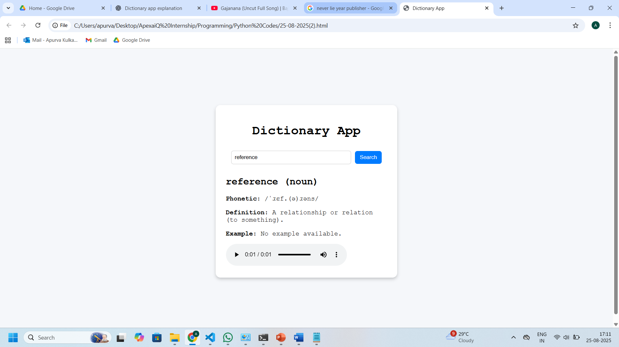

**Conclusion**

JavaScript is more than just a programming language—it is a core technology that drives the modern web. Its ability to add logic, interactivity, and functionality makes it essential for every aspiring developer. With concepts such as variables, data types, operators, conditionals, loops, functions, arrays, and objects, beginners gain the building blocks needed to solve problems and write efficient code. Mastering these basics is the first step toward exploring advanced topics like DOM manipulation, asynchronous programming, and popular frameworks like React or Node.js. By practicing consistently and applying these concepts in real projects, learners can unlock the full potential of JavaScript and move closer to becoming proficient developers.

***